Perfect Pour Over Coffee

Cindy Ho

Mark Golla

Zeeshan Virani

**Concept of Operations**

REVISION – Draft

9 February 2022

Concept of Operations

for

Perfect Pour Over Coffee

Team 14

Approved by:

____________________________

Mark Golla Date

_____________________________

Prof. Kalafatis Date

_____________________________

T/A Date

**Change Record**

| **Rev.** | **Date** | **Originator** | **Approvals** | **Description** |
| --- | --- | --- | --- | --- |
| **1** | 02/08/2022 | Mark Golla |  | Draft Release |

**Table of Contents**

**Table of Contents III**

**List of Figures** **V**

**1.** **Executive Summary 1**

**2.** **Introduction 2**

2.1. Background 2

2.2. Overview 2

2.3. Referenced Documents and Standards 2

**3.** **Operating Concept 3**

3.1. Scope 3

3.2. Operational Description and Constraints 3

3.3. System Description 3

3.4. Modes of Operations 5

3.5. Users 5

3.6. Support 5

**4.** **Scenarios 6**

4.1. Coffee Enthusiast 6

4.2. Office Environment 6

4.3. Handicapped or Disabled 6

**5.** **Analysis 7**

5.1. Summary of Proposed Improvements 7

5.2. Disadvantages and Limitations 7

5.3. Alternatives 7

5.4 Impact 7

**List of Figures**

# Figure 1: Software System Breakdown Model……………………….……......................

# Figure 2: Hardware System Breakdown Model……………………...……......................

# 

# Executive Summary

The company sponsor is looking for a way to automatically and consistently brew a perfect cup of pour over coffee. The proposed solution to this problem is a coffee maker that utilizes computer vision and machine learning algorithms to automate the pour over method and to adjust timings and temperatures based on user feedback for future pours. Computer vision is used to monitor the saturation of the coffee grounds as the heated water is poured to prevent oversaturation of the grounds. User feedback is gathered after each pour, which is used to reinforce a machine-learning algorithm to adjust water temperature and ground saturation limits. This algorithm will, over each iteration, narrow in on the perfect settings catered to each user so that the user can consistently have their perfect cup of coffee. The benefit of this product over existing technologies is that the machine adjusts its settings so that each user will be able to have a cup of coffee that is tailored and perfect for them.

# Introduction

Pour over coffee is a common method used to brew coffee where coffee is created by pouring heated water over the grounds until saturation, and intermittently adding more as the water filters through. Water is reintroduced at various intervals to keep the grounds at a certain saturation value. The advantage of this over a traditional drip coffee is increased control over water temperature and the rate at which water is added to the grounds. The issues with pour over coffee pertain to human errors and inconsistencies with pouring methods as well as the tediousness of having to produce it by hand. Our system aims to eliminate these issues within the pour over method and create the perfect cup of coffee tailored to each user.

## Background

The method is restricted in regards to tracking temperature and controlling water saturation levels. Our system focuses on automating the pour over coffee process by utilizing machine learning and built-in sensors to regulate temperature and water saturation levels. Rather than having the user heat and drizzle water over the grounds for personalized coffee, the user will be able to simply choose on the app what type of roast they prefer. Then our system will curate the perfect cup of coffee for that user based on their feedback from the previous brew. This reduces the amount of time a user will have to spend on using the “pour over '' method and eliminates any of the skills involved. Also, the system will brew the same perfect cup of coffee every time since there will be no human interference involved during the brew itself. A friend or family member would be able to brew their loved ones perfect coffee without worrying about messing it up.

## Overview

The three different types of roasts our system will cater to are light, medium, and dark roast. Our system will have preset temperatures and water saturation levels catered to each type of roast prior to the user. After the first usage of the system, the user will be able to relay feedback on the app to determine whether they enjoyed their coffee or not. This information will be stored in the database and depending on the evaluation given, the system will adjust the temperature and water saturation levels. Machine learning will be used to adjust these measurements and compare it to previous data to curate the perfect brew for the next time.

## Referenced Documents and Standards

* [FDA - CFR Title 21](https://www.accessdata.fda.gov/scripts/cdrh/cfdocs/cfcfr/cfrsearch.cfm)
* [FCC Title 47- Part 15](https://www.govinfo.gov/content/pkg/CFR-2009-title47-vol1/pdf/CFR-2009-title47-vol1-part15.pdf)
* <https://www.seriouseats.com/make-better-pourover-coffee-how-pourover-works-temperature-timing>
* https://resource.bunn.com/library/pdf/coffee_basics_brochure_scae_english.pdf
* <https://www.ctahr.hawaii.edu/oc/freepubs/pdf/EN-3.pdf>
* <https://realpython.com/python-ai-neural-network/>
* <https://home.howstuffworks.com/coffee-maker.htm#:~:text=On%20the%20left%2Dhand%20side%20of%20the%20base%20of%20the,aluminum%20tube%20heat%20the%20water>.
* <https://www.barniescoffee.com/blogs/blog/the-difference-between-pour-over-and-drip-brew-coffee>

# Operating Concept

## Scope

The system aims to brew personalized cups of coffee for every individual user by modulating the temperature and water saturation level according to the coffee’s roast type and user preferences. It will learn and adjust those two parameters every time it brews depending on the user's evaluation to ensure the next cup is a step closer to being catered perfectly to the user.

## Operational Description and Constraints

The system is designed to be added to the typical consumer’s kitchen ecosystem. Each user will create a user profile, which will be constructed using default brewing parameters. To start a brew, the user will add water to the reservoir, place their preferred grounds onto the filter, and enter the quantity of coffee along with their roast selection into the user interface. The brewing sequence will start and the progress will be displayed. At the end of the sequence, the user will be alerted, by both the machine and the app, that their coffee is ready. Afterwards, the grounds can be disposed of, the filter rinsed, and the finished coffee rated.

The operational constraints are as follows:

* Must be connected to smartphone for any of the app’s functionality to be used
* Designed for indoor use only
* The device, except for the carafe and filter, must not be immersed in water
* The device may only brew with coffee grounds (not tea or other beverage powders)
* The camera lens must be clean and unobstructed for proper performance

## System Description

The system can be described in three separate subsystems: hardware (sensors and brew control), database and machine learning, and lastly the android app.

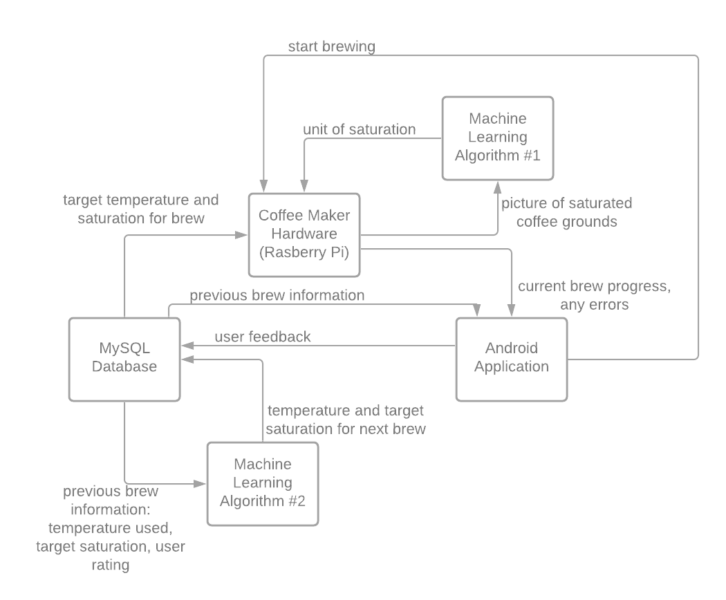

*Figure 1: Software System Breakdown Model*



*Figure 2: Hardware Control System Breakdown Model*

**Hardware User Interface:** The user will be able to select a user profile under which their settings will be saved, then enter the roast type and desired brew amount. The user will interact with a minimalist interface of an OLED display and set of directional buttons. The interface will also present basic information during the brewing process such as progress.

**Control System and Sensor Array:** The brains of the device will be a Raspberry Pi 4B which will interface with the locally stored brew database, receive user input from the user interface, and run the brewing script which will involve the control of the water heating and dispersion system while collecting feedback from the sensors. To aid the primary function of the device, a temperature sensor for water temperature and multispectral camera to track saturation will be employed. The multispectral camera will communicate with a machine learning algorithm to translate the captured image of the grounds to a saturation value. Other sensors designed for user safety such as thermal runaway detection and carafe detection will be added.

**Brewing Hardware:** The heart of the brewing action is performed by the water heating and dispersion system. The water must be heated quickly and accurately to around boiling point and be well distributed across the grounds in controlled intervals. The heating system will use a resistive heating element, common to automated coffee makers, to heat the water before it flows into the grounds’ chamber. The flow of water will be controlled by a sprinkler system that will actuate open and closed to maintain the target saturation value provided by the database. By tracking the rate of water distribution, the quantity dispensed will also be tracked.

**Database:** The MySQL database will contain the light, medium, and dark roast’s corresponding temperature and water saturation value along with all of the user’s feedback after each brew. This data will be updated based on the machine learning algorithms and the evaluation from the user.

**Machine Learning:** The machine learning subsystem will consist of two algorithms. During the brew process, the classification algorithm determines how saturated the ground beans are based on image processing. Prior, the classification algorithm will be trained by images of saturated ground beans at varying amounts to determine the initial brew temperature and water saturation level. To generate the perfect cup of coffee, the regression algorithm will take the user’s feedback and predict the temperature and water saturation levels for the same user’s next brew.

**Android App:** The android application will be created in Java and use the smartphone’s wifi capabilities to connect to the raspberry pi along with the database. The application will retrieve user data from the database to display history of previous pours and provide information on their device’s maintenance. The application will also be able to start the brewing process on the coffee maker by sending a signal to the raspberry pi to begin the whole process. The raspberry pi will also send data back to the application to update it on its progress which will be shown to the user. This will also allow the user to receive a notification when their coffee has been poured.

## Modes of Operations

There are two ways to operate the coffee maker. One will be through the built in display that will have the basic controls for the coffee maker. This includes the ability to start the brewing process and provide feedback on each cup of coffee. For more advanced features and insight, there is an android application. The application will also allow the user to start the coffee maker and provide feedback but will also give the user historical information on their previous pours, a help guide with frequently asked questions, and maintenance information.

## Users

Coffee Enthusiasts are our main target user. Our product is made for those who are looking for a more personalized and perfected coffee experience. This coffee machine will adjust its brewing settings based on the user’s preferences and over time learn to brew the perfect cup of coffee for the user. Even though coffee enthusiasts are the main target audience, any one who is wanting to make their own coffee can benefit from this product. Our product takes away most of the effort needed to create pour over coffee by using machine learning in order to learn each user’s specific coffee preferences. Anyone can set up the device as there is an included instruction manual that goes over how to initially get the device running and how to maintain it over time.

## Support

Support will be provided through an in app page that will include frequently asked questions, common issues and how to deal with them, as well as maintenance for the device to keep it running smoothly. If these options are not sufficient for the user, a contact email for our development team will be available for additional support. An online pdf manual will be provided in the app and on the website and a paper manual will be included with the product that will go over initial setup instructions and proper maintenance. The app will also have an initial setup guide when it is first opened that will show the user how to set up the device and get it ready for its first use.

# Scenarios

## Coffee Enthusiasts

More experienced coffee drinkers are most sensitive to slight changes in tastes of coffee and that varies drastically from person to person. For those people looking to get a more personalized pour over coffee experience will truly benefit from this product. Our coffee maker will learn each individual user’s coffee preferences and adjust its timings and temperatures accordingly to create the perfect cup of coffee for each user.

## Office Environment

In a large scale corporate office, there are all different types of coffee drinkers. This machine allows all the users to have their own profiles that would adjust the coffee pouring to suit their taste. One machine in an office space can handle many users as long they connect their device to the coffee maker. Afterwards, the coffee maker will work the same as if only one person is using it. The data that it gathers will be specific to each user to ensure that everyone is getting their perfect cup of coffee every morning.

## Handicapped or Disabled

This coffee maker would automate the pour over method for those who are incapable or have disabilities that prevent them from making coffee this way. This also allows those users to be able to have the perfect cup of coffee as free-handling may be difficult or dangerous due to the weight and temperature of a kettle.

# Analysis

## Summary of Proposed Improvements

The standard coffee brewing system isn’t very smart; it performs the simple task of pouring hot water over coffee grounds without regard for the subtleties of how hot the water is or how quickly it's introduced. For those who want more control over their brewing experience, the pour-over is the method of choice. This method relies on the user manually heating and pouring boiling water over the grounds in short intervals to ensure that the grounds are evenly wet and never oversaturated. Even this though leads to inconsistencies in the brewing experience as small characteristics from changing water temperature to pour speed affect the quality of the brew. Through the automation of this process, every facet of the brewing process is able to be fine tuned and made repeatable. While other solutions for pour over coffee exist on the market, this device will provide unparalleled performance thanks to its unique sensor array featuring optical saturation monitoring and ability to learn and adapt user preferences over time.

## Disadvantages and Limitations

While perfectly usable offline, the device performs best when it has a wireless connection. In the absence of this, it will no longer be able to perform firmware updates or connect with the app for viewing the history of previous pours or receiving notifications when the brewing process is complete. The user would also not be able to see troubleshooting information or maintenance information.

Some other coffee solutions allow for other beverage programs such as tea or hot chocolate. Our design will only be designed for the brewing of hot coffee from coffee grounds as our algorithms will not be trained to deal with anything else.

## Alternatives

Our proposed method of saturation tracking for the grounds is a camera system that translates multispectral images to saturation values. While this system should work in theory, it may need to be assisted by more traditional moisture sensors in order to reach the required accuracy.

In most traditional automated coffee systems, water is boiled in small quantities and the boiling action propels the water through the tube and onto the grounds. Meanwhile, pour over coffee typically relies on using a kettle to boil all the water at once allowing for precise control of the water's temperature by timing how long it's been off boil. At this time, we’d like to use the traditional automated system, and if we don’t see the temperature control we’re after, then we’ll move to experiment with a more kettle-like heating design.

## Impact

The system will have a washable, reusable stainless steel coffee filter. This should positively impact the environment by eliminating the waste that comes with the use of paper filters. The app will also advise within the user guide that coffee grounds can be disposed of as compost rather than contributing to a landfill.